Application of Light Gradient Boosting Machine (LightGBM) for Expected Goals (xG) Value Prediction in Football Analysis

Fadhil Raihan Akbar
Faculty of Science and Technology, UIN Syarif Hidayatullah Jakarta, Indonesia
E-mail: fadhil.ra101@gmail.com
*Corresponding Author

Qurrotul Aini
Faculty of Science and Technology, UIN Syarif Hidayatullah Jakarta, Indonesia
E-mail: qurrotul.aini@uinjkt.ac.id

Nida'ul Hasanati
Faculty of Science and Technology, UIN Syarif Hidayatullah Jakarta, Indonesia
E-mail: nidaul.hasanati@uinjkt.ac.id

Yuni Sugiarti
Faculty of Science and Technology, UIN Syarif Hidayatullah Jakarta, Indonesia
E-mail: yuni.sugiarti@uinjkt.ac.id

Muhamad Nur Gunawan
Faculty of Science and Technology, UIN Syarif Hidayatullah Jakarta, Indonesia
E-mail: nur.gunawan@uinjkt.ac.id

Received: Date Month, Year; Revised: Date Month, Year; Accepted: Date Month, Year; Published: Date Month, Year

Abstract: Modern football analysis faces challenges in calculating Expected Goals (xG) metrics accurately and efficiently. Traditional linear models are less capable of reading football data relationships, particularly shot data, while more complex models require very long computational times. The benefit of xG is to assess the probability of a goal occurring from a shot taken by a player; xG is used by coaches, analysts, commentators, and football fans to assess shot quality. This study applies the Light Gradient Boosting Machine (LightGBM) algorithm within the Knowledge Discovery in Databases (KDD) framework to build an xG prediction model using a public dataset from StatsBomb consisting of 73,844 data points. The objective of this research is to evaluate the improvement in accuracy performance and computational efficiency proposed by LightGBM in predicting xG values. The performance results of the LightGBM model show superior improvement when compared to various gradient boosting models from previous studies, with specific metrics: Brier Score 0.0621 and ROC AUC 0.9209. In terms of efficiency, the LightGBM model was able to complete the training process in just 49.75 seconds, far outperforming other comparison models. As a practical implementation, this research also produced an interface for direct visualization and xG prediction. This study makes a significant contribution to modern football analysis by presenting a LightGBM-based model proven to be superior in accuracy and computational efficiency, thus offering a practical solution for better xG modeling.

Index Terms: Football analysis, data mining, expected goals (xG), machine learning, LightGBM.

1. Introduction
In the era of big data, sports analytics has become a vital component in strategic decision-making. Football, traditionally judged by the final score, is now evaluated using advanced metrics, one of which is Expected Goals (xG). xG measures the probability of a shot becoming a goal based on the characteristics of that shot, such as distance, angle, and the body part used [1].

Although xG has become an industry standard, the main challenges lie in prediction accuracy and ease of interpretation. Traditional models like Logistic Regression often fail to capture complex non-linear relationships between game variables. Therefore, modern Machine Learning approaches such as Gradient Boosting have become promising alternative solutions. The Light Gradient Boosting Machine (LightGBM) algorithm was chosen in this study due to its efficiency in handling large datasets and its high accuracy compared to other tree-based algorithms [2].
In addition to model accuracy, the gap between technical analytics and lay users (coaches, pundits, fans) remains an issue. Complex mathematical models are difficult to understand without adequate visualization. This research focuses not only on building an accurate xG model but also on developing a web-based User Interface using the Streamlit framework. The goal is to provide an intuitive decision support tool where users can validate their tactical intuitions through empirical data.
This research aims to fill this gap by applying the Knowledge Discovery in Databases (KDD) approach to develop an accurate xG prediction model using the LightGBM algorithm, and integrating it into a web-based User Interface using the Streamlit framework. The systematic KDD approach was chosen to ensure the data processing from raw to knowledge (model and visualization) is carried out in a structured and valid manner.

2. Related Works
This section discusses theories and previous research relevant to the development of Expected Goals (xG) models. The xG concept was first popularized by researchers such as Green and Pollard who attempted to measure the efficiency of shots. Rathke's research [1] developed an xG model to evaluate shot efficiency using logistic regression. His findings confirmed that spatial variables, particularly distance and angle of shot, are the most significant predictors in determining the probability of a goal. However, the limitations of linear models in capturing complex interactions have led to the use of more sophisticated methods.
Eggels et al. [3] focused on explaining soccer match outcomes with goal scoring opportunities predictive analytics. Furthermore, Anzer and Bauer [4] proposed a goal scoring probability model for shots based on synchronized positional and event data in football.
In the domain of algorithms, LightGBM has shown promise in various fields. For instance, Hartanto et al. [2] utilized LightGBM for stock price time series forecasting, demonstrating its efficiency.

3. Proposed Approach
This study adopts the Knowledge Discovery in Databases (KDD) framework to ensure a systematic data analysis process. The research stages include Data Selection, Preprocessing, Transformation, Data Mining, and Evaluation, as illustrated in Fig. 1 [5].
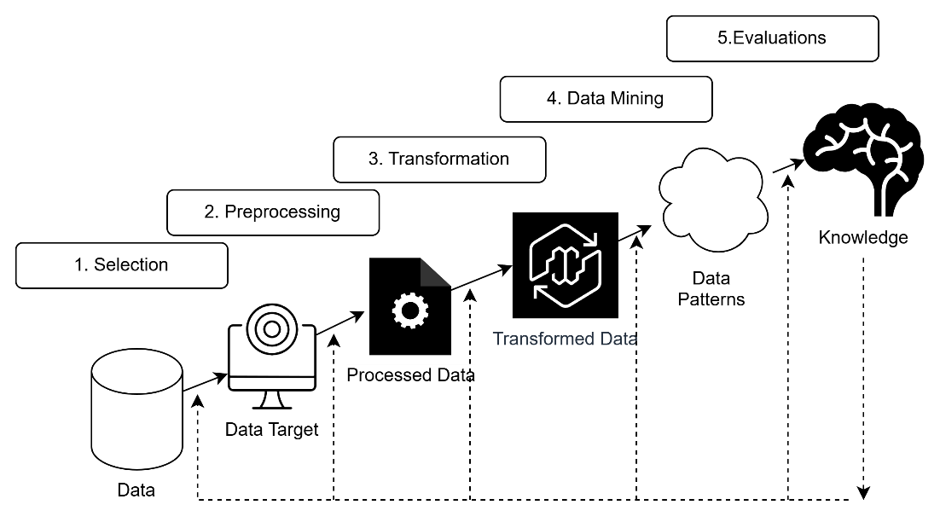
Fig.1. Research Stages.

3.1. Data Selection
This study uses secondary data obtained from StatsBomb Open Data [6]. To maintain consistency in game patterns and tactical validity, the data was filtered using the following criteria: (1) Men's soccer competitions, and (2) Professional level (Non-Youth). The final dataset includes thousands of shot event data collected from various top European leagues. Fig. 2 shows a sample of the raw data.

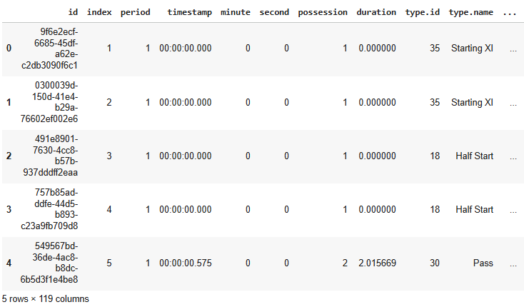
Fig. 2. Raw Data Sample.

3.2 Preprocessing & Transformation
At this stage, raw data is cleaned and reformatted to be suitable for modeling. The steps include:

- Handling missing values and removing irrelevant or redundant features.
- Field coordinate data $\left(x,y\right)$ is processed into new features: Distance to Goal and Shooting Angle. The distance ($d$) is calculated using the Euclidean formula from the shooting point $\left(x, y\right)$ to the center of the goal $\left(G_{x}, G_{y}\right)$, defined as:

$$\begin{aligned}d = \sqrt{\left\{{\left(G_{x}- x\right)}^{2}+ {\left(G_{y}- y\right)}^{2}\right\}}\#\left(1\right)\end{aligned}$$

The shooting angle ($θ$) is calculated using the inverse tangent function to measure the shooter's angle of view relative to the goal mouth width ($w$), as shown in Eq. (2) [7]:

$$\begin{aligned}θ= arctan\left.\left(\frac{w ⋅\left(G_{x}- x\right)}{{\left(G_{x}- x\right)}^{2}+ {\left(y - G_{y}\right)}^{2}- {\left(\frac{w}{2}\right)}^{2}}\right.\right)\#\left(2\right)\end{aligned}$$

- Categorical features such as body part, play pattern, and shooting technique are used directly based on their ID (identification number) values without additional encoding, because the LightGBM algorithm can process these numerical inputs effectively.
The features used are summarized in Table 1.
Table 1. Data Feature Columns.
No | Name | Data Type | Attributes
1 | period | Numerical (ID Category) | Contextual
2 | minute | Numerical (Integer) | Contextual
3 | second | Numerical (Integer) | Contextual
4 | start_x | Numerical ( Float ) | Spatial
5 | start_y | Numerical ( Float ) | Spatial
6 | distance_to_goal | Numerical ( Float ) | Spatial
7 | angle_to_goal | Numerical ( Float ) | Spatial
8 | position | Numerical (ID Category) | Contextual
9 | shot_outcome (target) | Numerical (ID Category) | Target
10 | shot_body_part | Numerical (ID Category) | Technical
11 | shot_first_time | Boolean | Technical
12 | shot_one_on_one | Boolean | Contextual
13 | shot _open_ goal | Boolean | Contextual
14 | shot_aerial_won | Boolean | Contextual
15 | shot_key_pass | Boolean | Contextual
16 | possession | Numerical (Integer) | Contextual
17 | play_pattern | Numerical (ID Category) | Contextual
18 | under_pressure | Boolean | Contextual
19 | shot_technique | Numerical (ID Category) | Technical

3.3 Data Mining
This stage is the core of the KDD process, where patterns are extracted using Machine Learning algorithms. This study uses the Light Gradient Boosting Machine (LightGBM) algorithm [8]. This process includes:

- Data splitting: Dividing data into training and testing sets using 90:10 ratio.
- Hyperparameter tuning: Using RandomizedSearchCV to find the optimal parameter combination (learning rate, n_estimators, num_leaves) to prevent overfitting.
- Model calibration: Applying isotonic calibration so that the predicted probabilities accurately represent the actual probabilities of events.

3.4 Evaluation
To validate the performance of the proposed LightGBM model, three primary aspects are evaluated: discrimination capability, probability calibration, and computational efficiency.

- ROC-AUC (Discrimination), the Receiver Operating Characteristic - Area Under Curve measures the model's ability to distinguish between positive instances (goals) and negative instances (no goals) across various threshold settings. It is defined as the area under the ROC curve, which plots the True Positive Rate (TPR) against the False Positive Rate (FPR) as shown in Eq. (3) [9]:

$$\begin{aligned}AUC = \int_{\left\{0\right\}}^{\left\{1\right\}}{TPR\left(FPR\right)d\left(FPR\right)}\#\left(3\right)\end{aligned}$$

- Brier Score (Calibration) metric is utilized to assess the accuracy of the predicted probabilities, which is critical for xG models. It represents the mean squared difference between the predicted probability and the actual outcome, as shown in Eq. (4) [10]:

$$\begin{aligned}BS = \frac{1}{N} \sum_{i=1}^{N}{{\left(p_{i}- o_{i}\right)}^{2}}\#\left(4\right)\end{aligned}$$

where $N$ is the total number of shots, $p_{i}$ is the predicted probability of a goal, and $o_{i}$ is the actual outcome (1 if goal, 0 otherwise).
- Computation time (Efficiency) used to assess the efficiency of the proposed method, the total execution time is measured, encompassing both the hyperparameter tuning process (RandomizedSearchCV) and the calibration process. This ensures the model is feasible for large-scale or real-time analysis.

4. Experiments and Results

4.1 Exploration Data Analysis
The results of descriptive statistical analysis provide initial insights into the characteristics of shots in soccer. As shown in Fig. 3, the distribution pattern of shot distance provides information about the quality of opportunities.

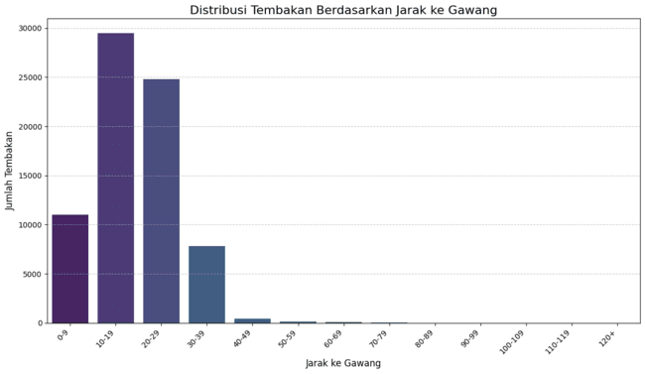
Fig 3. Distribution of Data Distance to the Goal.
The data in Fig 3 shows a higher concentration of shots at shorter distances, which correlates with higher scoring probabilities. In addition to distance, the distribution of shot angle is also a crucial factor in determining xG. This is shown in Fig. 4.

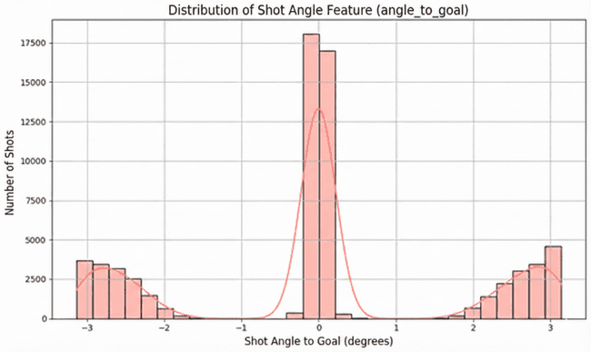
Fig 4. Distribution of Data Angle to the Goal.
The histogram on Fig 4 shows that players predominantly select central shooting angles to increase the visible goal area, as evidenced by the high frequency density in the central bins.

4.2 Model Performance
Model evaluation was conducted to measure prediction reliability. Fig. 5 shows the ROC (Receiver Operating Characteristic) curve of the trained LightGBM model. The area under the curve (AUC) of 0.92 indicates that the model has good discrimination capabilities in distinguishing between potential goals and non-goals.

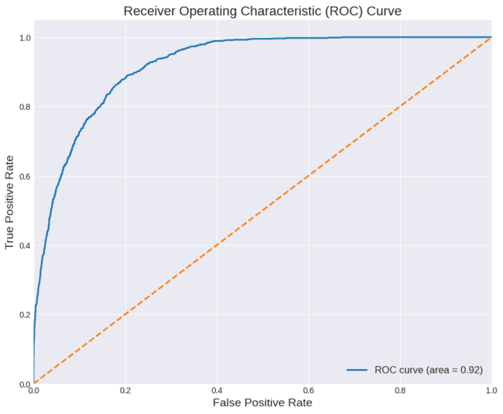
Fig 5. ROC Curve.
In addition to classification capabilities, probability accuracy is measured using a calibration curve as shown in Fig. 6.

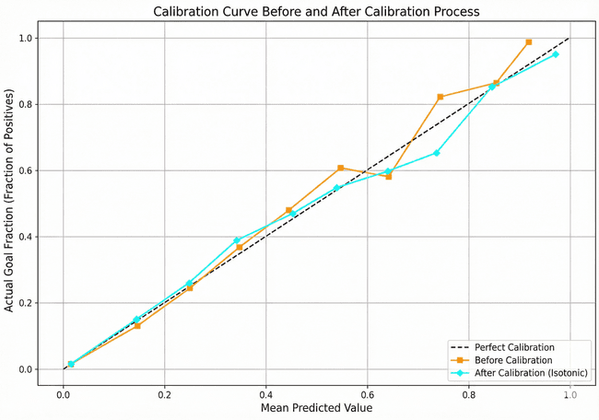
Fig 6. Calibration Curve.
The plot on Fig 6 illustrates the reliability of the predicted probabilities, supported by a low Brier Score of 0.0621, indicating that the model's confidence levels closely match the actual goal outcomes. Table 2 summarizes the evaluation metrics.
Table 2. Model Evaluation Results.
Evaluation Metric | Score
ROC-AUC | 0.92
Brier Score | 0.0621
Second (time) | 49.75

To validate the significance of the proposed approach, Table 3 presents a comparison with other studies in this domain. The proposed LightGBM model demonstrates superior performance in terms of accuracy compared to previous methods.
Table 3. Comparison of Performance Metrics with Related Studies.
Study | Model | Brier Score | ROC AUC
Eggels et al. (2016) [3] | Ada-Boost | - | 0.670
Anzer & Bauer (2021) [4] | Gradient Boosting Machine | - | 0.822
Cavus & Biecek (2022) [11] | LightGBM | 0.173 | 0.818
Senn (2024) [12] | XGBoost | - | 0.718
Mead et al. (2023) [7] | XGBoost | 0.0799 | 0.800
Proposed Method | LightGBM (with Calibration) | 0.0621 | 0.9209

4.3 User Interface Implementation
The final stage is interpretation, which is realized through an interactive web application. Fig. 7 shows the main display of the developed application using Streamlit.
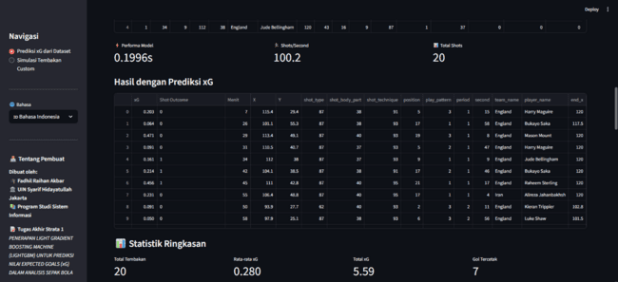
Fig. 7. Streamlit-Based xG Prediction Application Interface Display.
This interface allows users to input match variables in real-time and visualize the calculated xG probability instantly.

5. Conclusion
This study successfully applied the Light Gradient Boosting Machine (LightGBM) algorithm within the Knowledge Discovery in Databases (KDD) framework to predict Expected Goals (xG) values with high precision. Based on the experimental results, the proposed model demonstrated significant performance improvements compared to previous studies, achieving an ROC AUC of 0.9209 and a Brier Score of 0.0621. These figures confirm that the model possesses excellent discrimination capabilities in distinguishing goal opportunities, as well as a highly accurate level of probability calibration. In terms of computational efficiency, the model proved to be exceptionally fast, completing the training process in just 49.75 seconds, significantly outperforming other comparison models.
The primary benefit of the resulting accuracy and efficiency is the provision of a feasible analytical solution for large-scale data processing in the modern football industry. Furthermore, the integration of this model into a web-based interface using Streamlit offers a crucial practical benefit: bridging the gap between complex mathematical models and non-technical users. This enables coaches, analysts, and fans to validate their tactical intuitions instantly based on empirical data. For future development, it is recommended to integrate player tracking features to account for the positions of defenders and goalkeepers, thereby enabling even more precise xG calculations.

Acknowledgment
The authors wish to thank A, B, C. This work was supported in part by a grant from XYZ.

References
- M. Rathke, "An examination of expected goals and shot efficiency in soccer," Journal of Human Sport and Exercise, vol. 12, no. 2proc, pp. S514-S529, 2017.
- A. D. Hartanto, Y. Nur Kholik, and Y. Pristyanto, “Stock Price Time Series Data Forecasting Using the Light Gradient Boosting Machine (LightGBM) Model,” JOIV : Int. J. Inform. Visualization, vol. 7, no. 4, 2023.
- H. Eggels, R. van Elk, and M. Pechenizkiy, "Explaining soccer match outcomes with goal scoring opportunities predictive analytics," in Proceedings of the 3rd Workshop on Machine Learning and Data Mining for Sports Analytics, 2016.
- G. Anzer and P. Bauer, "A goal scoring probability model for shots based on synchronized positional and event data in football (soccer)," Frontiers in Sports and Active Living, vol. 3, p. 624475, 2021
- A. Solanki and H. Sharma, "A Review on Knowledge Discovery in Databases," International Journal of Computer Applications, 2021.
- StatsBomb, "StatsBomb Open Data," GitHub Repository, 2022. [Online]. Available: https://github.com/statsbomb/open-data.
- J. Mead, A. O’Hare, and P. McMenemy, "Expected Goals In Football: Improving Model Performance And Demonstrating Value," PLoS ONE, vol. 18, no. 4, p. e0282295, 2023.
- G. Ke et al., "LightGBM: A Highly Efficient Gradient Boosting Decision Tree," in Advances in Neural Information Processing Systems, 2017, pp. 3146–3154.
- F. S. Nahm, "Receiver operating characteristic curve: overview and practical use for clinicians," Korean Journal of Anesthesiology, vol. 75, no. 1, pp. 25–36, 2022.
- G. W. Brier, "Verification of forecasts expressed in terms of probability," Monthly Weather Review, vol. 78, no. 1, pp. 1–3, 1950.
- M. Cavus and P. Biecek, "Explainable expected goal models for performance analysis in football analytics," in 2022 IEEE 9th International Conference on Data Science and Advanced Analytics (DSAA), vol. 45, pp. 1–9, 2022.
- W. Senn, "Addressing Evaluation Challenges On The Expected Goals (xG) Metric In Football Analysis," Bachelor's Thesis, Geneva School of Business Administration, 2024.

How to cite this paper: Firstname A. Lastname, Firstname B. Lastname, Firstname C. Lastname, "Paper Title: Preparations of Papers for the Journals of the MECS Press", International Journal of Intelligent Systems and Applications, Vol.14, No.6, pp.1-4, 2022. DOI:10.5815/ijisa.2022.06.01

